**Exp 5 Design an Automatic Night Lamp**

**CIRCUIT DIAGRAM**

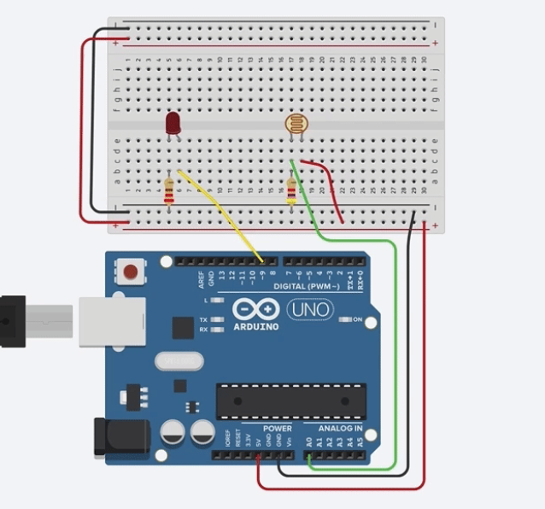

**THEORY**

**CONCEPT USED**

An LDR is a component that has a (variable) resistance that changes with the light intensity that falls upon it. This allows them to be used in light sensing circuits. The resistance of a LDR decreases with increasing incident light intensity.

With this changing resistance ON and OFF of a lamp can be controlled.

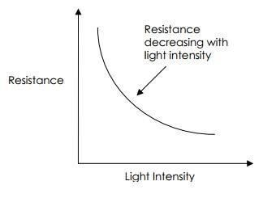

**LEARNING AND OBSERVATION**

Instead of controlling an LED according to the brightness and darkness, controlling home lights or any electrical equipment become easy. Adding specific code according to the requirement light intensity can be controlled.

**PROBLEM AND TROUBLESHOOTING**

While making the circuit, connection are needed to be maintained corrected. Problem which I faced while performing is that , an error in a coding leads to disfunction of a program.

**PRECAUTIONS**

1. Connections must be tight and correct.
2. Coding must be right.
3. Components used must be working properly.
4. Before uploading the program , Arduino must be connected.
5. It is better to keep the circuit switched off when it is not in use.

**LEARNING OUTCOMES**

Automatic night lamp as the name suggests is for turning ON and OFF the lamp automatically without the need of human interventions. It senses the light intensity from surroundings and find whether its day or night. And it automatically turns ON when the surrounding is dark and it turns OFF when it receives light from surroundings. A sensor called LDR is used to detect the light intensity. This project finds wide outdoor applications in streets, gardens and public places where it finds difficulty to appoint a person to operate the lights.